5 WAYS TO WELLBEING
The 5 ways to wellbeing have been shown to improve your mental health and overall wellbeing through simple steps

TAKE NOTICE
Taking in the environment around you and practicing mindfulness. Allow yourself to take a moment then focus on your feelings, your thoughts, what’s happening around you – take notice of what you can hear, the colours or shapes you can see, what you can smell. This process can help you to calm yourself and reduce feelings of anxiety. It can be really helpful especially during these challenging times to make time to slow down, reflect and take in the environment.
Recognising what helps you or affects your mood and take notice of anything that is having a negative impact. On the flip side, what helps you feel good? For example notice how you feel during and after sports let yourself enjoy how good you feel.

Notice activities
Senses Challenge - Go for a walk outside and ask your young person to notice or find five examples of each of the senses. What sounds can you hear? Colours you can see or patterns in the clouds, different textures you can feel and different smells. This is a really good way to help everyone to focus on their surroundings, to keep them in the present. You can create a checklist for each family member and see what everyone finds.
Each family member pick their favourite song- close your eyes and listen how does the music make you feel? Focus on the instruments used, the patterns in the music and the lyrics used.
Fire breathing dragons – this is a simple mindfulness breathing exercise for young children following these steps….Breathe in deeply to the count of 4, exhale from the back your throat making a dragon style noise at the same time, pretend you are breathing out fire think about how far can the fire reach, can the fire change colours? Take in turns with your young child/children to be the dragon. This activity is a fun way of getting them to focus on the breathing and think about how it feels.
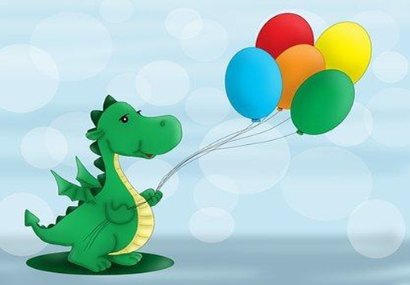

GIVE/HELP OTHERS
By helping others you are also helping yourself. The process of giving and helping others in turn helps to improve our own mood, increasing your feelings of happiness and improving your mental wellbeing overall.
This can be through giving time, giving support or emotional help, showing people kindness, sharing your knowledge, your enthusiasm - all of this is a way of helping others. Showing kindness to others helps to improve your mood because it creates positive feelings and it give you a sense of reward at the same time. For example checking in with your family – showing them you are thinking about them with a simple text or quick phone call shows people that want to check in and see how they are doing. A small gesture like that can make a big difference to someone feeling lonely.
Offering to help could be through volunteering or maybe donating your unwanted goods to a local charity shop. All these acts will reinforce the benefits of giving and this in turn will help to increase your own sense of purpose.

Give /help others activities
Kindness notes- each member of the family could write a note to each other telling them their favourite things about them.
Make a card for someone you care about draw a picture of something that reminds you of them – show them you are thinking about them.
Learn how to help – can you become eco-aware recycling in the home is a great way to start. Think about how you, your family and your household make positive changes to improve the environment and give back to the planet.

BE ACTIVE
Physical activity has a positive impact on our health, lifestyle, and our mental wellbeing. If you are not usually very active then try by starting small and work up to creating a routine doing some form of activity every day this could be gardening, dancing or walking. Being active increases our energy, our mental alertness and improves our mood.
Small changes to incorporate more activity into your life can make big differences so set small regular goals. Set yourself some time regularly to be active; it can help if you set the time and days as you may be able to stick to it more. If you can’t commit to longer activities, break it down into smaller chunks of activity of at least 10 minutes. Regular bursts of activity help to enhance our mental wellbeing through releasing feel good hormones which in these difficult times is more important than ever.

Be active activities
Superhero musical statues – get all the family up and dancing around but remember when the music stops you all need to strike a superhero pose and keep that position until the music starts again.
Star jump challenge- set a timer for 1 minute and see how many star jumps each family member can do in that time – can you beat your best score?
Treasure hunt – children will select their favourite toy – their ‘treasure’. Then take it in turns to hide the item somewhere in the home and time it to see who can find the ‘treasure’ the fastest.
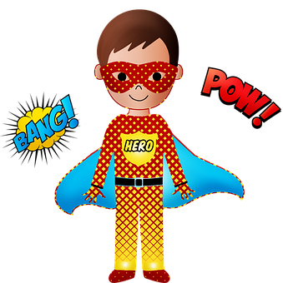

CONNECT
Social interactions are crucial to mental wellbeing. Having a social network and people to talk to – helps to increase your own feelings of happiness and self-worth. This is both meeting new people and staying connected with those around you.
During these difficult times stay in touch with your family, friends and school friends– you may not be able to see each other like you normally would but by staying in touch you are helping yourself and others during these challenging times.
Friendships/connections with family is a way in which all of us gain support and encouragement. This then improves our mental wellbeing and our ability to get through difficult situations.

Connect activities
Take 5 pictures of things around your home that you make you happy and share your pictures with your family. Did you pick any of the same – think about why you made your choices.
All about me - Write a quiz for a school friend or family member trying to find out more about them and send by post or email if you are able to. Write an ‘all about me’ list for yourself - your favourite sport, favourite word, favourite movie etc. Ask them to reply with their answers and set you more questions. You might learn new things about the person and you will show them you are thinking about them.
Family games night – set each other challenges, test each other’s knowledge or play cards and board games. Have fun and feel connected.

KEEP LEARNING
Learning can help your mental wellbeing. Learning new knowledge and developing new skills has been shown to improve self-confidence, self-esteem and our resilience as well.
It could be a new topic you are interesting in learning more about or revisiting a past hobby and improving your skills. Maybe trying a new recipe or listening to a podcast, there are lots of options. Setting yourself a goal and trying something new helps to give you a sense of achievement and improve your confidence at the same time.

Keep learning activities
Teacher time – Parents have had to become teachers during home schooling so this is a chance for the children to become the teachers. They can choose to explain a book or video game or information on their favourite toy to the rest of the family and then set a quiz to see what everyone else has learned.
Get Cooking -Try out a new recipe together and get everyone involved in the food preparation. This is a good way to have a think about nutrition and talk about where food comes from. It also helps children learn more about kitchen safety and food hygiene. There are lots of free recipe ideas online or you could ask family and friends to share their top recipes for you to test out.
Observation checklist -When you are having a walk around your local area try and learn more about it and take notice of your surroundings. You could draw up a checklist for the types of buildings you want to spot library, Doctors, schools or places of worship.

