Gratitude Journal

Mood of the week – which one did you feel like the most this week……..
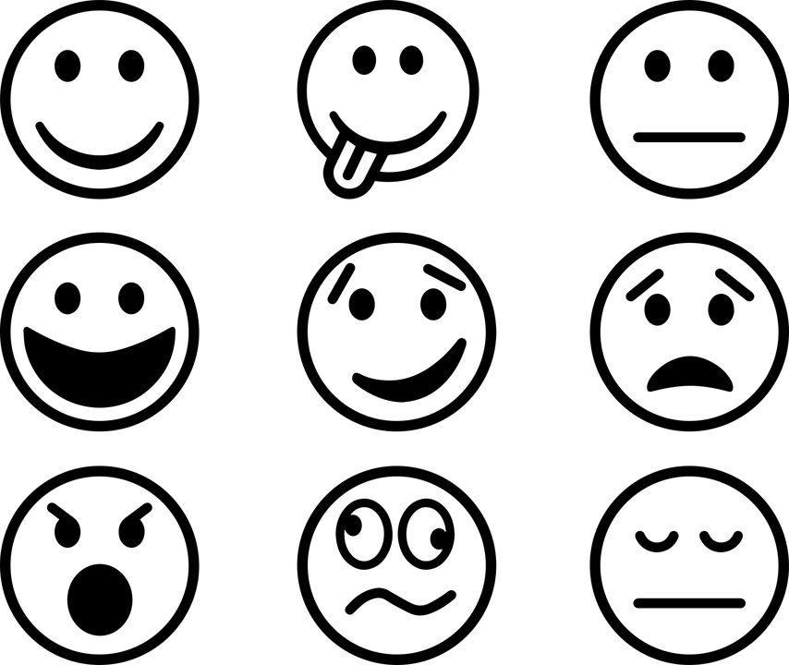

And why?

This week the three things I’m most grateful for are -

Today I smiled because -

This week I laughed the most when -

Draw a picture of someone who is a kind person

Write a thank you note to someone who has helped you because showing our thanks to others helps you to feel happier yourself

Draw a picture of a happy memory – who were you with, what can you remember the most?

