Mindfulness outdoor activities

Sometimes it’s so easy to get wrapped up in our day to day routine – we are so busy with our daily task rushing from task to task that it becomes difficult for us to slow down, to stop for a moment and actually take in our surroundings and for us to recognise how we truly feel within ourselves as well.
It’s important to make time to slow down, reflect and take in the environment. Through doing this and taking in the environment around us its helps our health and mental wellbeing. By allowing yourself to slow down and take notice this can help reduce feelings of anxiety.
A good way to do this is a mindful walk/ mindful scavenger hunt.
Go for a walk down your street but try and look at it through a difference you hear difference sounds at different times of the day.
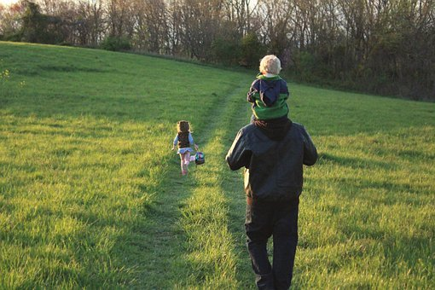

Scavenger hunt
Listen –
What can you hear on your walk?
Wind?

Cars?

People talking?

Birds chirping?

The sound of insects?

What else can you hear- focus on the sounds of your surroundings.

Feel
What does the wind feel like on skin?
How does the ground feel under your shoes?

See
What colours can you notice?
What patterns can you see – this might be patterns made by the clouds or on signs.

Smell
What can you smell?
Are there flowers around?
Take in some slow deep breathes in and out as you walk around.
