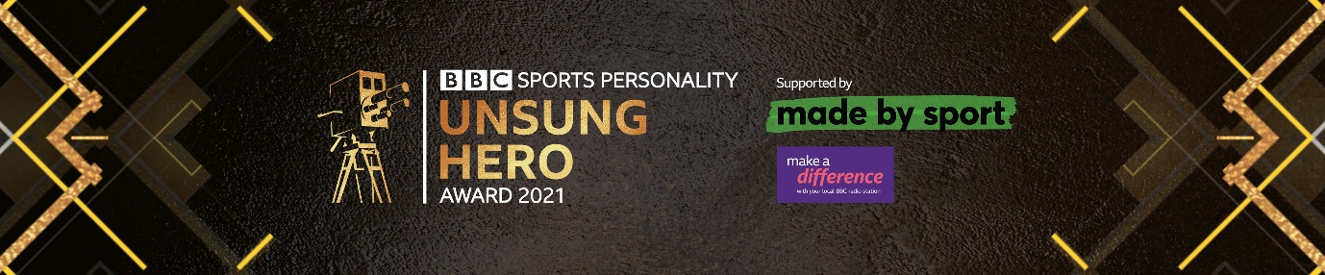

BBC Sports Personality of the Year Unsung Hero 2021 – email nomination form
Tell us all about your amazing volunteer right here. The closing date for nominations is 23:59 on 17th October 2021.
Once completed, please email your form to us at unsunghero@bbc.co.uk
Any entries received after this time cannot be accepted for the 2021 award.

Tell us all about your Unsung Hero;
Explain fully why they deserve the award.
- What makes them special?
- What is their greatest achievement in the last twelve months?
- How do they provide opportunities for people who wouldn't otherwise play sport or activity?
- What do colleagues or club members have to say about them?
- Please include as much information as you can. The more we know about your Unsung Hero the better they will score in judging.
You can submit your nomination by email to unsunghero@bbc.co.uk. Please note in the subject line of your email ‘Unsung Hero – nominee’s name’.
If you want to nominate someone and you are younger than 18, ask your parent or guardian and they must complete the form for you.

Maximum 800 words

Contact details of your nomination
Please note that we will contact the nominee, or their parent/guardian. You should not submit a nomination without getting permission from the nominee or their parent/guardian first. They will be contacted by the BBC and we will mention your name when we contact them.
Their name

Post code

Contact number or email address

Which BBC region do they live in?

If your Unsung Hero is younger than 18, please provide details for their parent or guardian. We cannot accept the entry without this information.
Parent/guardian name

Either parent/guardian contact number

Or parent/guardian email

About you
Your name
Post code

Contact number

Email address

I confirm that I am 18 or over, or have completed this form with someone over 18.
I have informed my Unsung Hero that I have nominated them or their parent/guardian if they are younger than 18.
I have read and agree to the Award Rules and to the BBC’s Terms of Use.
I have read the BBC Unsung Hero Awards Privacy Notice.

