

**srowbotham@longfield.leics.sch.uk**

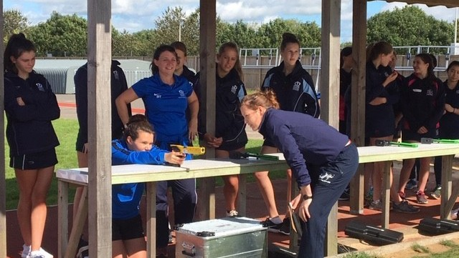

**COME AND HAVE A GO AT LASER RUN**



**Laser Run is the exhilarating finale to the Olympic sport of Modern Pentathlon with athletes required to alternate between shooting a laser pistol and running in a fast-paced and action-packed race to the finish line.**

**Open to ages 7 and upwards and all levels of abilities - with no previous experience necessary - the Discover Laser Run series presents a unique opportunity for keen runners to add a new dimension to their racing.**



**To enter follow these instructions:**

**For more information:**

**Long Field Spencer Academy**

**Melton Mowbray**

**Saturday 7th May**

**9am – 2pm**

**Your local event:**

**Haven’t shot a Laser pistol before? Don’t worry! The Discover Laser Run series 2022 is open to all levels of abilities.**