THE LEICESTER, LEICESTERSHIRE AND RUTLAND LIVING WELL WITH DEMENTIA GRANT FUND 2022
ROUND 1 1st April – 31st May 2022 – SMALL GRANTS UP TO £5,000
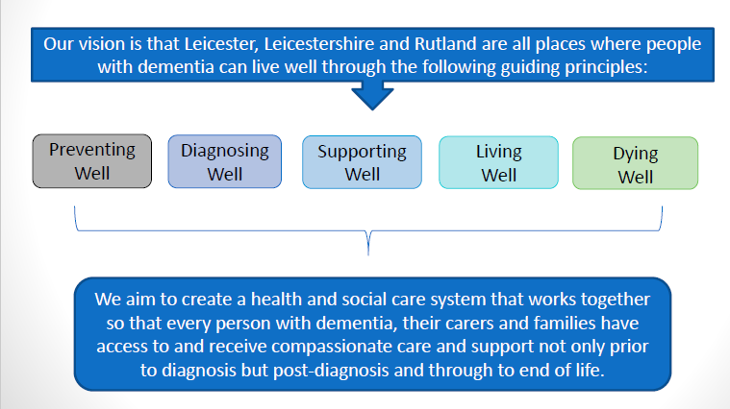
The voluntary and community sector (VCS) contributes an enormous wealth of expertise and experience to support the health and wellbeing of the population of Leicester, Leicestershire, and Rutland (LLR). The partners meeting as the Dementia Programme Board would like to support VCS organisations to continue and develop their work with people living with dementia and their family or informal carers.

A small fund of non-recurrent funding will be available in two rounds in 2022. VCS organisations can apply for grants in multiples of £500 up to £25,000 for:
- New projects/services
- Existing projects/services
- Capital items to support projects/services (items are required to be value for money and organisations may be asked to document quotes)
- Revenue costs (staffing, management, and monitoring)
- Part of the costs of a project/service
- All the costs of a project/service
- LLR wide or district/town/village/neighbourhood/community* specific projects /services
  - *District/town/village/neighbourhood/community specific projects can only apply for grants up to £5,000.
IMPORTANT! Round 1 (1st April 2022 – 31st May 2022) is aimed at organisations bidding for grants of up to £5,000
Round 2 (1st July 2022 – 31st August 2022) is aimed at organisations bidding for grants of over £5,000

Outcomes
The grant is for projects/ services that enhance the vision of the LLR Dementia Programme Board. We ask that grants meet one or more of the following outcomes:
- Meets our Dementia Programme Board vision (above)
- Supports people with or without a formal diagnosis of dementia
- Supports people waiting for an appointment with Memory Assessment service
- Supports Carers of people with Dementia
- Supports seldom heard groups¹
Criteria
- VCS organisations are to have a legal form and bank account or have an agreement with an accountable organisation
- The project/service must meet one or more of the highlighted outcomes (see above)
- Submissions can be for projects/services that are LLR wide or district/town/village/neighbourhood or community specific. The maximum grant for district/town/village/neighbourhood/community specific projects will be £5,000.
Monitoring and Reporting
- Projects will be monitored quarterly (proportionally to the size and remit of the project)
- Organisations will be required to supply an end of project evaluation report.
- The service must have a clear delivery plan and achievable measurable outcomes
- The service must demonstrate benefits to people using it and the Dementia Programme Board partners.

Evaluation
Applications will be evaluated by panel members who will then meet and moderate their scoring. From the application form, questions 3, 4 and 5 will be scored on a scale of 0-5. The panel will include a person living with dementia, a carer and a representative from an independent organisation (to ensure a transparent and fair process. The independent organisation is unable to apply for a grant.)
Due diligence will also be undertaken and is why we ask for your charity / company details.
Depending on your project, you may be asked for additional information, to clarify and answer and/or be asked to provide one or more of the following organisational policies / procedures.
- Safeguarding
- Information Governance
- Health and Safety
- Equality and Diversity Policy
- Risk Assessments
- Data Protection
- Complete a conflict-of-interest form.
¹ The term 'seldom-heard groups' refers to under-represented people who use or might potentially use health or social care services and who are less likely to be heard by these service professionals and decision-makers.
Examples of seldom heard groups could include:
- Ethnic minority groups - Carers
- People with disabilities - Lesbian, Gay, Bisexual, Transgender, and Queer people
- Refugees/asylum seekers - People who are homeless
- Younger people - People with language barriers
Voluntary and Community Sector Grant Application Form
This form is to be used when bidding for a VCS grant from the LLR Dementia Programme Board.
Your application will be considered against set evaluation criteria, by the VCS Grants Panel along with other applications.
Please fill in the grant application form below and then send it by e-mail to the VCS Grants Panel at <address>
You should refer to any documentation relating to the project grant you are applying for (if applicable) and please also read the guidance notes (in red) as you complete the form.
Please note that by submitting an application, you agree to providing a project evaluation
Name of your group / organisation
Main contact
Position in group / organisation
Address
Postcode
Email address
Telephone No

1. Project Title
Please give a name for your project.
2. Project Outline
Please describe your project.
3. Which outcome does your project meet?
Delete as appropriate and write a short summary outlining how you think your project will meet the priority.

- Meets the Dementia Programme Board vision and at least one of the Guiding Principles (please state which one/s below)
- Supports people with or without a formal diagnosis of dementia
- Supports people waiting for an appointment with Memory Assessment services
- Supports seldom heard groups
4. What are the outcomes and impact you would expect from the project and how would the funding make a difference?

5. How will this project benefit people living with dementia and the partners in the Dementia Programme Board?
Please think about improving access, quality, experience, outcomes and efficiency.

6. Is this a new or an existing project?
Please provide detail if new or existing.

7. Who will benefit from the project?
Please outline here which group/s your project is aimed at e.g. seldom heard communities, older people, young onset dementia, family carers, people with learning disabilities with dementia etc. or “all.”

8. Which populations will your project support?
Please select from the list below. You are welcome to provide additional information / explanation.
- Leicester City
- All of Leicestershire
- Blaby
- Charnwood
- Harborough
- Hinckley and Bosworth
- Melton
- North West Leicestershire
- Oadby and Wigston
- All of Rutland
- Whole of Leicester, Leicestershire & Rutland (LLR)
- Any others, e.g. towns, villages, neighbourhoods, communities – please state (LLR council areas only)

9. Amount required
Please give details of the full project costs per annum and the amount you require for this project. You are unable to apply for a bid that exceeds the grant limit. Please provide a breakdown of cost e.g. staffing, support, premises, equipment, training etc.

10. What other funding or in-kind support can you bring (added value)?
Please give us details on what you will contribute - anything that you/your organisation already have in place that can be brought to project. You might want to include existing teams, volunteers, networks, venues, experience, assets etc.

11. Start / End date with brief timeline and delivery plan
Please refer to the application guidelines and include in here the start and end dates of your proposed project.

12. Sustainability
The VCS grant is non-recurrent funding. Will the project continue after its end date? If yes, please state how you will fund this.

13. Governance
Please include an outline of the people in your group / organisation responsible for overseeing delivery of this project e.g. Your Board. Include information about how often they meet, the type of group / organisation you are e.g. registered charity and whether you have a constitution or terms of reference. If you are not an organisation with a legal form and a bank account, you can still apply but please arrange for an accountable organisation to receive and manage the fund on your behalf and include their overheads in the amount required (section 7).

14. People involved in the project
Please include here brief details of who will run, manage, and monitor the project. You do not need to list people by name, role/positions will suffice.

15. Conflicts of Interest
Please tell us if anyone key in your organisation or this project has a financial, professional, or personal conflict of interest with the Dementia Programme Board partners.

Please Note:
Depending on your project, you may be contacted for additional information, to clarify and answer and/or be asked to provide one or more of the following organisational policies / procedures.
- Safeguarding
- Information Governance
- Quality Assurance of your organisation
- Health and Safety
- Equality and Diversity Policy
- Risk Assessments
- Data Protection
- Conflict of Interest
Please return your completed application form to: dementia-grant@leicester.gov.uk
All applications will be acknowledged, and evaluation for round 1 will begin on the week commencing the 6th of June. We aim to notify successful organisations by the 1st of July. For round 2 evaluations will begin during the week commencing the 1st of August. We aim to notify successful organisations by the 1st of September.

