Dear Applicant,

Thank you for requesting an application pack for the role of Programme Coordinator at Get Berkshire Active.

In this pack you will find:

- Background information on Get Berkshire Active
- Job Description and Person Specification
- Application form

Please complete the application form (please do not send a CV) together with a cover letter (no more than 2 pages) outlining your reasons for applying for this role and return to ryan.gordon@getberkshireactive.org by no later than SUNDAY 14TH APRIL 2024.

Proposed interview date: WEDNESDAY 1ST MAY 2024

Good luck with your application and we look forward to receiving it.

Yours faithfully,

Brett Nicholls
Chief Executive Officer
Get Berkshire Active
Get Berkshire Active – Background Information

Get Berkshire Active (GBA) is the Active Partnership for Berkshire, one of 43 such partnerships working in England as local strategic partners to Sport England. GBA is a Charity and was formed in Sep 2011.

Our Vision: Inspired people and communities creating a happier, healthier more resilient Berkshire.
Our Mission is to be passionate about the value and benefit of Physical Activity. We will collaborate across all sectors, locally and nationally, using our skills, knowledge and resource to ensure equitable provision and participation in physical activity to address wider social outcomes and inequalities.
GBA provides leadership, strategic direction and support to a wide range of organisations involved in physical activity.
More about GBA here

Get Berkshire Active Equality Statement of Intent

Get Berkshire Active is fully committed to the principles of equality of opportunity and is responsible for ensuring that no job applicant, employee, volunteer or member receives less favourable treatment on the grounds of age, gender, disability, race, ethnic origin, nationality, colour, parental or marital status, pregnancy, religious belief, class or social background, sexual preference or political belief.

You can read about our commitment to Equality, Diversity and Inclusion here.

JOB DESCRIPTION

JOB DESCRIPTION

Job Title:  Programme Coordinator | Location: Hybrid (Office and Home based) GBA Office: Bisham Abbey National Sports Centre, Marlow Road, SL71RR
Line Manager:  Lead for Workforce and Network Resilience | Hours of work: Fulltime (Part-time considered)  Type of contract: Permanent
Salary: £26000-£30000  Good range of benefits including 25 days annual leave(increasing 1 day per year of service up to a maximum of 5 days), 10% employer pension contribution, flexible working (hours and location)  Starting salary depends on experience | Line Reports: No direct line management responsibilities
WHY WORK FOR GET BERKSHIRE ACTIVE
At GBA we believe in the power of sport and physical activity to transform lives, and we are committed to creating a healthier, happier, and more resilient Berkshire. Joining GBA will mean you are at the forefront of that effort playing a vital role in making sport and physical activity more accessible to the individuals that need it most. GBA is committed to the growth and development of its employees, and the post holder will be fully supported and mentored to develop their expertise and role. We understand the importance of maintaining a healthy work-life balance. GBA promotes a flexible and supportive work environment, allowing our team members to excel in their professional roles while also enjoying their personal lives. The Programme Coordinator will be an integral part of the GBA team and work across various programme areas therefore we are seeking an individual who is adaptable and has a keen sense of teamwork and communication.
JOB PURPOSE
The Programme Coordinator will support Get Berkshire Active’s (GBA) strategic intent in delivering Sport England’s ‘Uniting the Movement’ strategy across Berkshire. The Programme Coordinator will play a crucial role in the planning, coordination, and delivery of GBA's diverse range of programmes and initiatives.

DESIGNATION OF POST AND POSITION WITHIN TEAM STRUCTURE
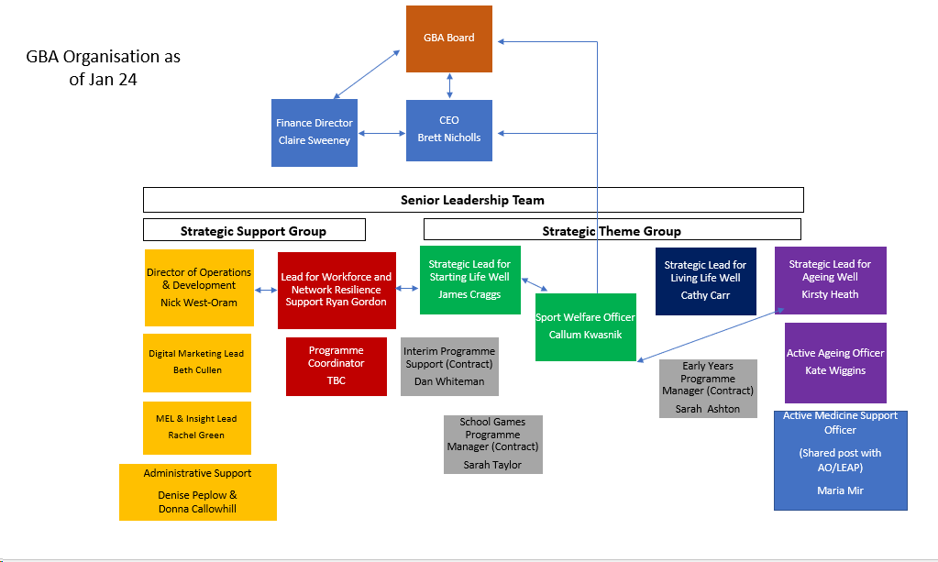
MAIN DUTIES AND RESPONSIBILITIES
The work areas listed below are just an indication, we are expecting the role to be varied in its nature with many opportunities to grow and develop both the individual and the role itself. This role is not just admin/desk based and will suit someone who is adaptable and has a keen sense of teamwork and collaboration and is willing to learn on the go.

- Work closely with Strategic Leads to coordinate the delivery of a range of GBA programmes, projects and initiatives.
- Assist in developing and implementing plans to increase partner engagement and participation in GBA's programmes and initiatives.
- Collecting case studies and information to generate impact reports
- Liasing with partners to collect and share best practice
- Support the Insight Officer to build strong Impact, Evaluation and Learning tools across our programmes
- Support on GBAs Leadership and Team Building Training
- Support across all main Workforce Development areas.
- Manage and lead on the coordination of GBAs Workforce Development Grants, which includes overseeing the budget, advertising to various partners, tracking impact of the grants etc
- Maintain accurate records and documentation related to programme activities.
- Collaborate with the marketing and communication team to promote GBA's programmes and initiatives through various channels.
- Oversee some sections of the website and daily maintenance of those sections
- Attend and assist in the planning and support of whole team events and team development days
- Development of a Quarterly GBA Workforce Newsletter along with Organisation and Workforce Spotlights
Undertake any other appropriate duties as directed by the line manager and or CEO
SCOPE OF JOB (Budgetary/Resource

PERSON SPECIFICATION
Experience:
 | CATEGORY | ESSENTIAL | DESIRABLE
1 | Experience of working and engaging with individuals from a wide range of backgrounds such as those that are unemployed/young people |  | ü
2 | Experience/ability to coordinate projects | ü
3 | Experience of working with underserved communities or groups |  | ü
4 | Experience of developing and maintaining excellent relationships with relevant organisations and individuals | ü
5 | Experience of working with partners to plan, monitor and report on projects | ü
6 | Experience of managing own workload without close supervision |  | ü
7 | Experience in delivery, either facilitating workshops/training or coaching sports |  | ü
8 | Experience of planning and supporting events such as forums |  | ü
9 | Experience of maintaining website pages |  | ü
10 | Experience of planning and co-ordinating training workshops |  | ü
11 | Experience of working within the sport, health, or physical activity sectors |  | ü
12 | Safeguarding experience |  | ü

Knowledge, Skills, and Abilities:
 | CATEGORY | ESSENTIAL | DESIRABLE
1 | Interest and passion for increasing participation in sport and physical activity. | ü
2 | Knowledge and experience of working with key agencies responsible for delivering support for hard to engage communities |  | ü
3 | Knowledge of key issues affecting underserved communities, social / community / economic development and personal development agendas | ü
4 | Passion for working with and helping those communities mentioned above | ü
5 | Showing initiative and taking responsibility | ü
6 | Excellent communication and written skills with the ability to develop and maintain relationships with a wide range of partners. | ü
7 | Project Management skills and understanding of processes |  | ü
8 | Competent use of Word and other relevant IT programmes | ü
9 | Ability to be adaptable and work in a team | ü
10 | Committed to equal opportunities for all | ü
Education:
 | CATEGORY | ESSENTIAL | DESIRABLE
1 | Degree educated in any related field |  | ü
2 | Evidence of continual professional development | ü

Other:
 | CATEGORY | ESSENTIAL | DESIRABLE
1 | Full UK driving licence with the ability to travel across Berkshire | ü
2 | Attend team meeting and development days (Every Second Wednesday) at our office site-Bisham Abbey | ü
3 | Occasionally work unsocial hours (evenings) |  | ü

PROGRAME COORDINATOR JOB APPLICATION FORM

Application for the post of: | PROGRAMME COORDINATOR
Closing date for Application : | SUNDAY 14TH APRIL 2024
Please fill in all sections and sign and date the declaration on the last page.
PERSONAL DETAILS
Title :
Surname : Forenames :
Address :

Postcode :
Date of Birth :

Telephone :
Mobile:
Email :
Preferred method of contact:

PRESENT OR MOST RECENT OCCUPATION
Organisation name :
Job Title :
Current Salary :
Hours per week :
Date started :
Date left (if applicable) and reason for leaving :
Brief description of duties :

QUALIFICATIONS AND CPD :
Educational establishment attended | Qualifications obtained, with dates and grades where applicable

PREVIOUS OCCUPATIONS Please enter most recent first and continue on a separate sheet if necessary. You may include both paid and voluntary roles.
Organisation: | Job Title: | Start date: | Leaving date:
Salary and hours: | Reason for leaving:
Organisation: | Job Title: | Start date: | Leaving date:
Salary and hours: | Reason for leaving:
Organisation: | Job Title: | Start date: | Leaving date:
Salary and hours: | Reason for leaving:

REFERENCES
Please give the names of 2 referees who are able to comment on your ability to carry out this job. One referee must be you current or most recent employer.
Name :  Address :  Postcode : | Position :  Capacity known to you :  Telephone number :  Email address:
Name :  Address :  Postcode : | Position :  Capacity known to you :  Telephone number :  Email address:
Your referees will only be contacted if you are short-listed for interview.
Are you happy for Get Berkshire Active to contact your referees prior to interview Yes/No

SUITABILITY FOR THE POST – PLEASE ADDRESS ALL AREAS OF THE PERSON SPECIFICATION.
Please say why you are applying for this post. Outline aspects of your previous experience and skills showing how they will help you fulfil the requirements of this role as outlined in the attached Job Description and particularly the Person Specification. No more than 2 sides of A4 please.

Eligibility to work in the UK
Are you legally eligible to live and work in the UK in accordance with the Asylum and Immigration Act 1996? YES / NO (please delete as applicable).
If appointed, you will be required to provide a specified document, such as a valid passport, P60, UK birth certificate or work permit to confirm your answer.
Rehabilitation of Offenders
The Rehabilitation of Offenders Act (ROA) allows most convictions and all cautions, reprimands and final warnings to be considered spent after a certain period. This period – known as the rehabilitation period – is determined by the sentence or disposal given, rather than by the type of offence. The ROA gives people with spent convictions, cautions, reprimands and final warnings the legal right not to disclose them when applying for most jobs.
This post is covered by the ROA. You therefore only need to inform us if you have any ‘un-spent’ convictions.

What does spent mean? Once a conviction, caution, reprimand or final warning becomes spent you do not need to disclose it to most employers, or when applying for most courses, insurance or other purposes (e.g. applying for housing). It is against the law for an organisation to obtain information about an individual’s spent cautions or convictions unless the law specifically states that they can ask an exempted question; usually when someone is applying for a job or role that is exempt from the ROA.’.

Do you currently have an UNSPENT convictions? YES / NO (delete as applicable). If yes we will write to you confidentially so that you can disclose these to us. If you are unsure the following is a good source of advice: ROA Advice

Availability for work: When would you be free to start in post?
Disability : If you require any adjustment to be made in the application procedures for this post due to a disability, or any particular arrangements in the event that you are called for interview, please record below and we will contact you with regard to making arrangements if you are called for interview.

Where did you hear about this post:

I declare that the information given in this application is correct to the best of my belief. I declare that I have no unspent convictions, and no pending cases that I have not brought to your attention which may affect my suitability to work with children, young people or vulnerable adults. I understand that should any information be false, a job offer may be withdrawn or I may be subject to summary dismissal.

Signed : Date :
(electronic signature is permissible)
Please email the completed form to Ryan Gordon ryan.gordon@getberkshireactive.org

EQUAL OPPORTUNITIES MONITORING

This form will be separated from the application Form prior to assessment of the forms and will not form part of the selection process. The data contained will anonymised and used solely for the purposes of monitoring the recruitment and selection processes of Get Berkshire Active.

You are free to complete all, some or none of this form.

Ethnicity
Asia/ Asian British - Bangladeshi
Asian/ Asian British - Indian
Asian/ Asian British - Pakistani
Asian/ Asian British - ‘Other’
Black/ Black British - African
Black British
Black/ Black British - Caribbean
Black ‘Other’
Chinese
White British
White European – Western Europe
White European – Eastern Europe
White Irish
Other

If none of the above seem to ‘fit’ you, please write in your ethnicity ..............................................

Gender

Male
Female

Disability

Do you consider yourself to have a disability, this may include long term illnesses or mental health conditions?

Yes
No

Please specify...................................................................................................................................

We do not currently collect data on either sexuality or religion.

