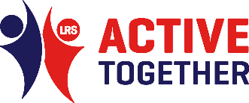
Physical Activity Messages for GP surgeries and PPGs
to share with patients and residents

- Take the messages/posts below and share these either on your communication channels.
- You may need to adapt some of the messages to suit platforms such as Twitter.
- To use the image, right click on the image, choose ‘Save as image’. Save the image and attach to your post.
- Tag us in if you can on Facebook, Twitter & Instagram:
Facebook: Active Together | Let’s Get Moving / Twitter @ActiveLLR
#LetsGetMovingLLR

Programme/ Resource | Copy | Suggested Artwork/Imagery
Generic Physical Activity Posts – Adults | Option 1 –  Keeping active is important for your mental and physical health. It can help improve your sleep, reduce stress, help you relax and make you feel better overall.  You don't have to run a mile, even the smallest amount of physical activity can make a difference. Find out how you can improve your wellbeing: https://www.active-together.org/wellbeing  #LetsGetMovingLLR | 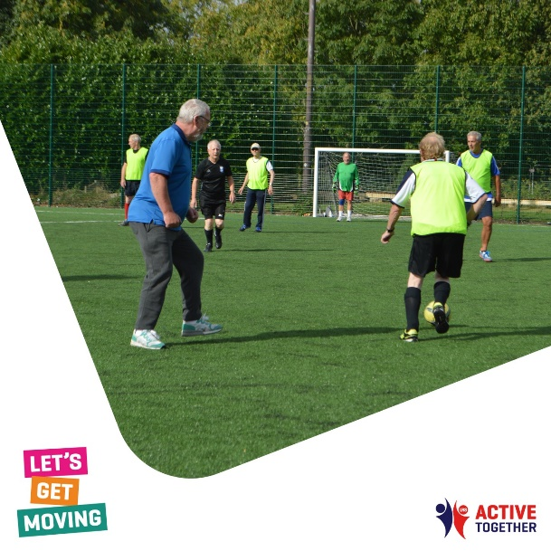
 | Option 2-  Being active shouldn't be a chore unless its housework; it should be fun! It's important that you find an activity that you enjoy, as you're more likely to keep going and move more each day.  Find something that works for you: https://www.active-together.org/getactive  #LetsGetMovingLLR | 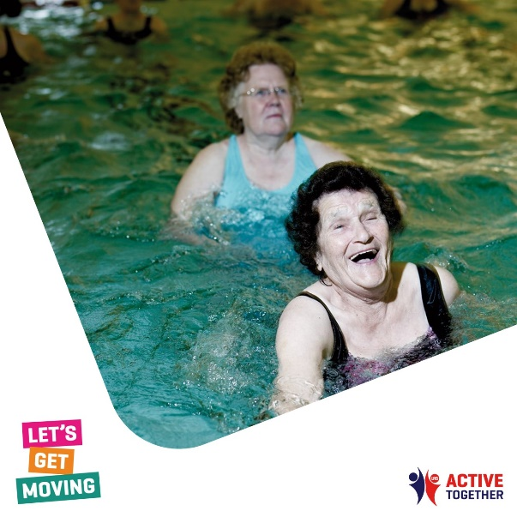
 | Option 3-  Your early morning thoughts set the tone for the rest of your day.  Productive days always start with a positive mind. Did you know that being active has a huge influence on improving your mood?  Early morning exercise, no matter how big or small, can result in boosting your mood for the rest of the day!  For information and tips on how you can be active, visit: https://www.active-together.org/dont-know-where-to-start  #LetsGetMovingLLR | 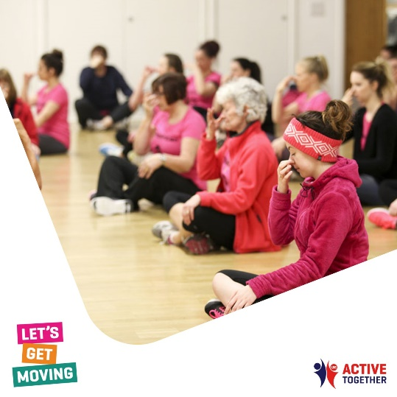
Active Mums Club – Pre- and post-natal women | Option 1)  The Active Mums Club  The place to go in Leicestershire to help you be active and look after your wellbeing during pregnancy and post natal.  Visit the website to join the club.  www.activemumsclub.org  Follow the socials to join the conversation.  Insta: @active_mums_club  Facebook: @ActiveMumsClub  Option 2)  Active Mums Club.  ‘We want to empower you to be active, not just to give your baby the best start but to make sure you are doing something for yourself too. We are the place to go in Leicestershire to help you be active and look after your wellbeing during pregnancy and post-natal. Whether you are looking for advice, things to do in your local area or people to meet.’  Visit the website to join the club.  www.activemumsclub.org  Follow the socials to join the conversation.  Insta: @active_mums_club  Facebook: @ActiveMumsClub  #LetsGetMovingLLR  #ActiveMumsClub | 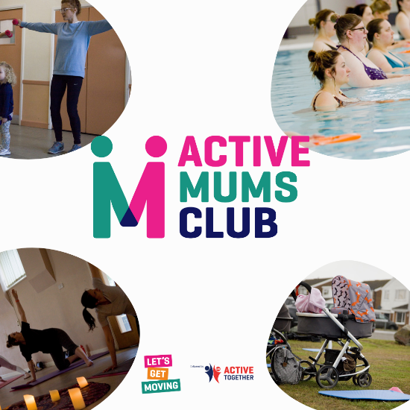
Long term health conditions | Option 1-  Physical activity is safe, even for people living with symptoms of multiple long-term conditions.  Regular physical activity, in combination with standard medical care, has an important role in the management and prevention of many long-term conditions.  Every movement matters!  Join the millions of people managing a range of health conditions who are finding ways to be active that work for them.  https://www.active-together.org/weareundefeatable  #LetsGetMovingLLR  Option 2-  People with long-term conditions are often fearful of worsening their condition from physical activity.  In fact, living an active life reduces your risk of getting many common diseases, including, Type 2 diabetes, hypertension, depression and more.  Every move enables more!  Join the millions of people managing a range of health conditions who are finding ways to be active that work for them.  Share your story with #WeAreUndefeatable  https://www.active-together.org/weareundefeatable  Option 3-  When living with a health condition, getting active can be challenging but building small amounts of activity into your day can boost your mood and even help to manage your mental health.  Find little ways to move more in a way that works for you https://www.active-together.org/weareundefeatable  #WeAreUndefeatable  #LetsGetMovingLLR | 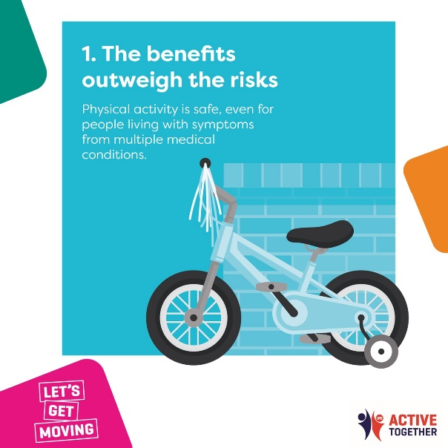  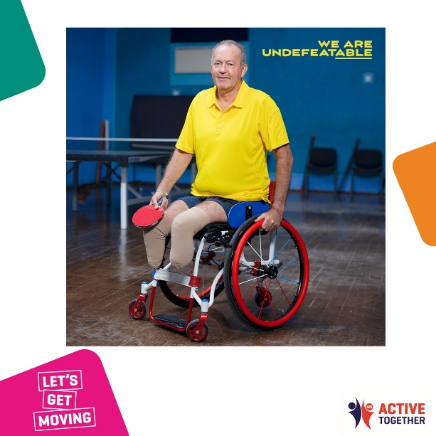  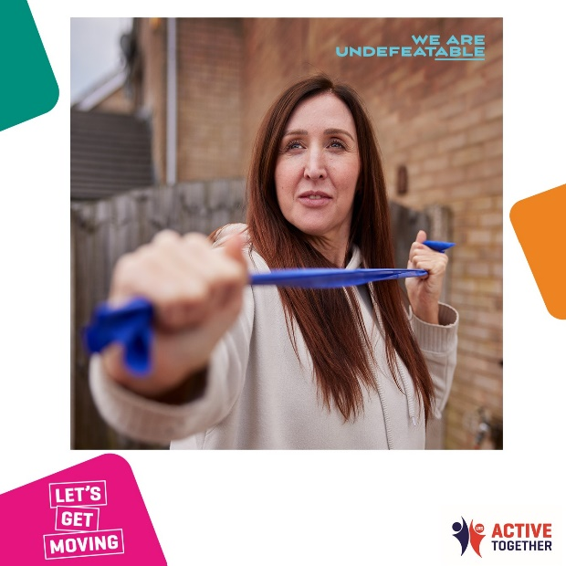
Falls prevention | Option 1 -  Maintaining and improving muscle strength and ability to balance is crucial to helping you live independently as you get older.  You can improve your own strength and balance by doing more activities like carrying shopping and doing the gardening as well as exercise like dance and tai chi.  For more information go to https://www.active-together.org/falls-prevention  #LetsGetMovingLLR  Option 3-  In older adults, poor muscle strength increases the risk of a fall by 76% and those who have already had a fall are three times more likely to fall again.  Strength and balance activities not only help to prevent this, but also help improve your mood, sleeping patterns, increase your energy levels, and reduce the risk of an early death.  For more information go to https://www.active-together.org/falls-prevention  #LetsGetMovingLLR  Option 3-  Top five ways to prevent falls;  •Look after your feet- Make sure your shoes/slippers keep your foot firmly in place.  •Stay Well- Eat healthily and regularly and always take your medicines on time and as prescribed.  •Look after your eyes- Have your eyes tested regularly – it's free if you're over 65  •Stay active, stay steady- Be active – try to do 30 minutes of moderate activity every day to help you maintain balance and muscle strength – this could be split across the day  •Look after your home- Replace worn floor coverings, remove clutter and ensure your home is well lit  For more information go to https://www.active-together.org/falls-prevention  #LetsGetMovingLLR | 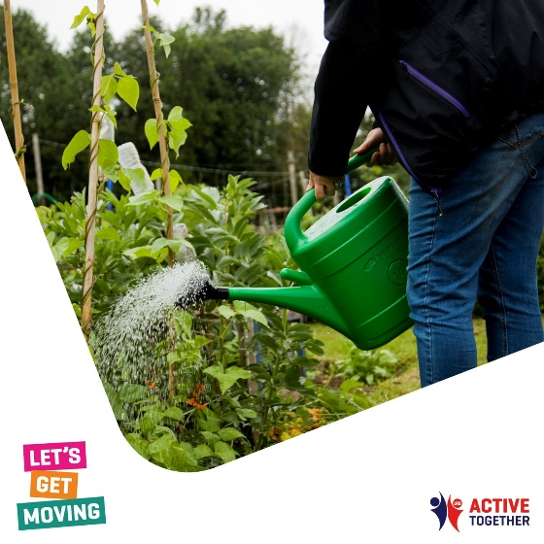  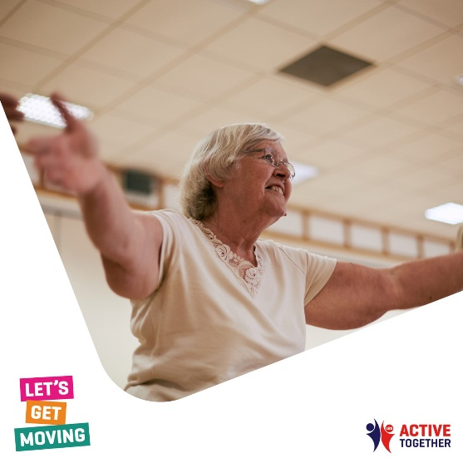  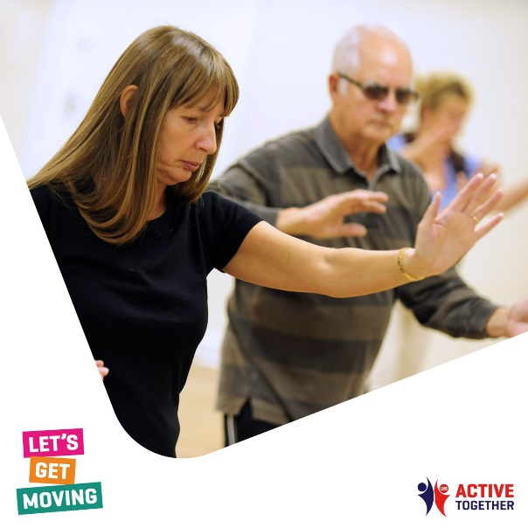
Walk, Run, Cycle Together | Option 1-  Are you looking for ways to spend more time outside in the fresh air while trying to stay healthy?  Why not explore your local area and discover new parks and open spaces.  Find out more: https://www.active-together.org/myway  #LetsGetMovingLLR | 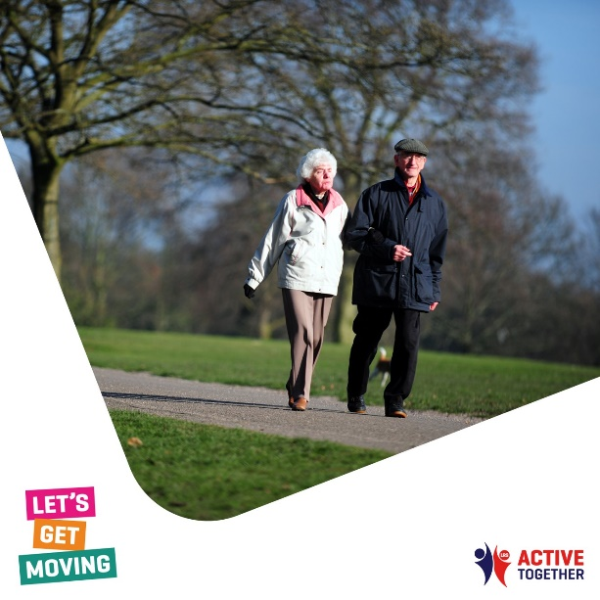
Champions | Option 1-  Do you want to be more active but aren't sure of the best way to start?  Take inspiration from our local #Champions and their stories, join in with @This Girl Can UK or catch up with the champions at @We Are Undefeatable and start your journey today!  Find out more: https://www.active-together.org/active-inspiration #LetsGetMovingLLR | 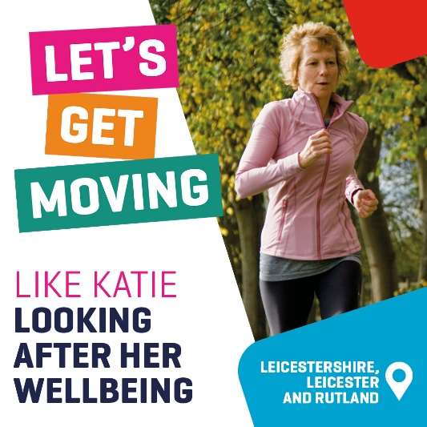
Get search engine! | Option 1-  Are you looking for new opportunities to be active?  Whether you join a new activity group, start a new hobby or embrace active travel, try something new in 2023!  Find an activity that's right for you with our Get Search Engine: https://www.active-together.org/getactive  #LetsGetMovingLLR | 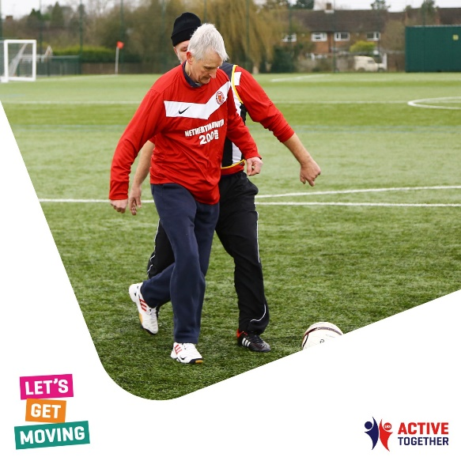
Generic physical activity posts- Active Families. | Option 1-  There are lots of ways you can be active as a family! The @ActiveLLR Active Families page includes tips, tricks, and resources to help you stay active as a family this year and make memories that'll last forever.  Find out more: https://www.active-together.org/active-families #LetsGetMovingLLR  Option 2-  Being active throughout half-term is a great way to improve your mind, body and health for you and your children whilst having much-needed family time.  Need inspiration on how to be active as a family this half-term? Take a look at some of the resources and ideas from the @ActiveLLR page and get your journey moving, together!  Find out more: https://www.active-together.org/active-children-and-young-people  #LetsGetMovingLLR | 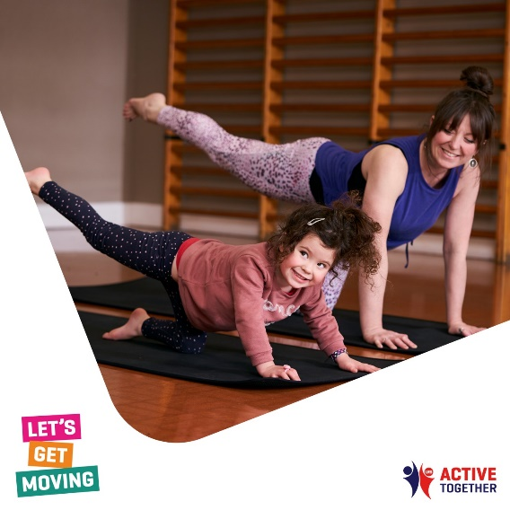  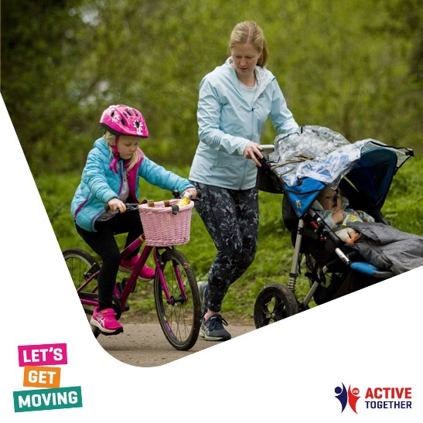
District specific | North West Leicestershire  There are lots of way you can be active in your local area.  Visit https://www.nwleics.gov.uk/pages/living_healthily to find an activity in NWL that works for you!  #LetsGetMovingLLR | 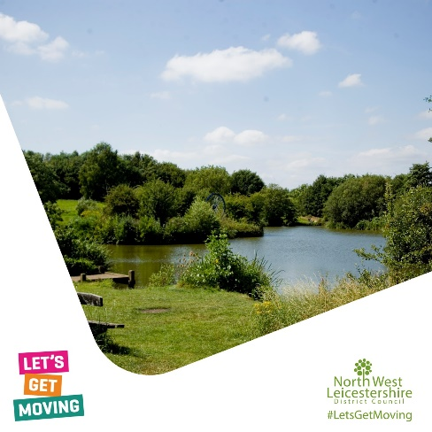
 | Charnwood  Option 1-  There are lots of way you can be active in your local area.  Visit https://www.active-charnwood.org/ find an activity in Charnwood that works for you!  #LetsGetMovingLLR  Option 2-  The Active Charnwood team delivers an array of different sports and recreation activities for the whole community to enjoy, such as recreational badminton, mini movers, walk programs, inclusive sessions, twilight games, pickleball, holiday activities and many more! 🎾🚶‍♀️  If you’re looking to get more active, improve your health, or meet new people, we have a session that suits you.  Head over to our website, https://www.active-charnwood.org/ , or email a member of the team at active.charnwood@charnwood.gov.uk to find out what we offer and what you can take part in  #LetsGetMoving  #ActiveCharnwood | 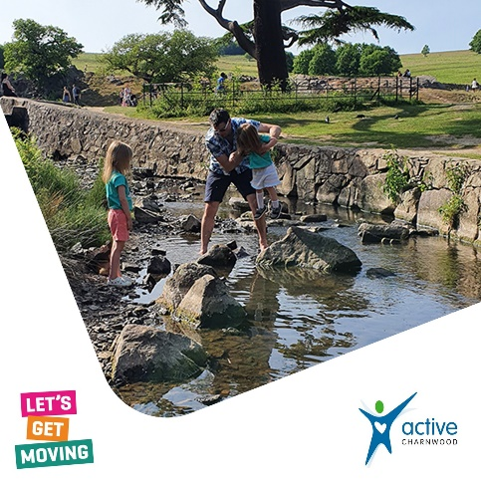
 | Option 3-  There are lots of way you can be active in your local area.  Visit https://www.meltonsportandhealth.org.uk/ find an activity in Melton that works for you!  #LetsGetMovingLLR | 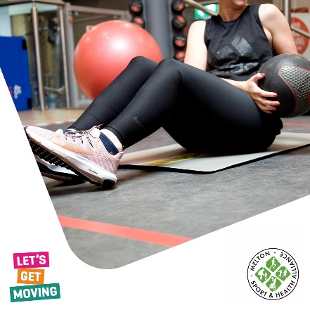
 | Option 4-  There are lots of way you can be active in your local area.  Visit https://www.leicester.gov.uk/leisure-and-culture/sport-and-leisure/ find an activity in Leicester City that works for you!  #LetsGetMovingLLR | 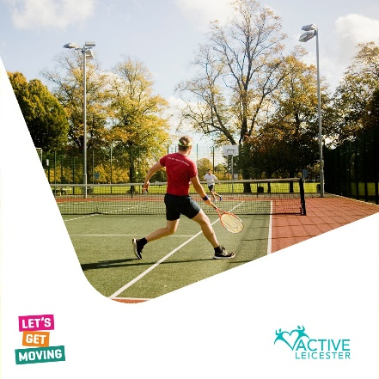
 | Option 5-  There are lots of way you can be active in your local area.  Visit https://www.hinckley-bosworth.gov.uk/fitness find an activity in Hinckley and Bosworth that works for you!  #LetsGetMovingLLR | 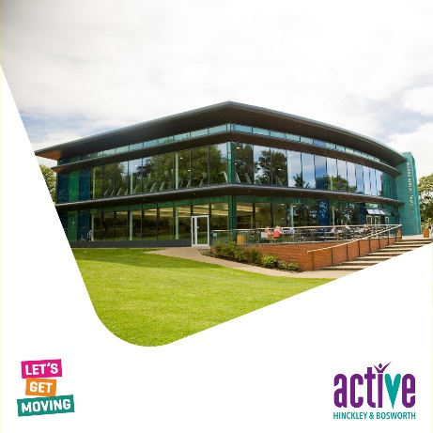
 | Option 6-  There are lots of way you can be active in your local area.  Visit https://www.active-harborough.org/ find an activity in Harborough that works for you!  #LetsGetMovingLLR | 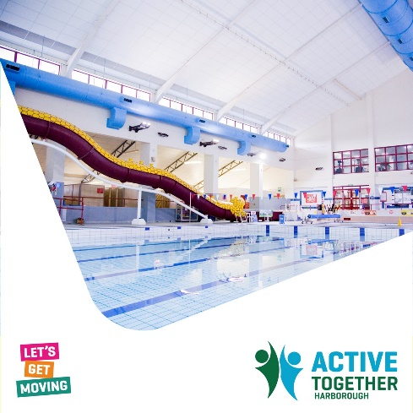
 | Option 7-  There are lots of way you can be active in your local area.  Visit https://www.activeblaby.org.uk/ find an activity in Blaby that works for you!  #LetsGetMovingLLR | 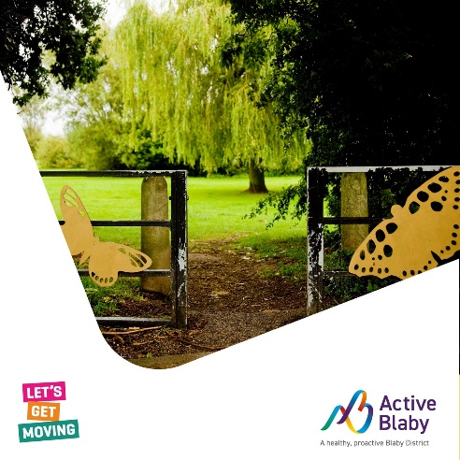
 | Option 8-  There are lots of way you can be active in your local area.  Visit https://www.activeoadbywigston.org.uk/ find an activity in Oadby and Wigston that works for you!  #LetsGetMovingLLR | 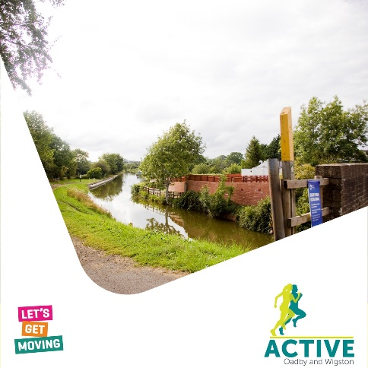
 | Option 9-  There are lots of way you can be active in your local area.  Visit https://www.activerutland.org.uk/ find an activity in Rutland that works for you!  #LetsGetMovingLLR | 