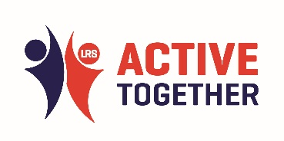
ACTIVE TOGETHER CONFERENCE 2023
Workshop: LSEG
What is your one key learning from this workshop?

LSEG | - Collaboration  - Inspiration  - Understanding more from co-existence to co-ownership  - People own what they create  - Start anywhere, but follow it everywhere.  - Importance of listening  - Connect with communities  - It’s time for massive action  - To be a person as well as a professional.  - Large challenged ahead but a common commitment to achieve  - Goose analogy! Know when to step back  - Reflection on good practice of collaborative programmes locally  - Remove a part of system and the rest has to work harder  - Real change happens in the work not the policy  - Get comfortable being uncomfortable  - Importance of communication and collaboration  - Encouraged and empowered to keep going  - Listening  - Follow the lead  - Be more goose  - More people within the system trying to make a difference – multiple organisations, the right people
What is the one action that you will take away from this workshop for you or your organisation?

LSEG | - More present in community and integration with key groups/communities. Asset mapping  - Look at Active Hope free resources  - Re-think work in communities, how can we adopt – open hearts and minds  - Organised another team building activity  - Challenge the status quo  - Continue working together  - Positive conflict can drive change  - To continue to embed the violence reduction agenda  - Need to discuss training and development  - To open up community dialogue a lot earlier and be led by the community  - Reset, refresh, reflect  - Follow up with people met doing interesting work

