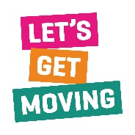
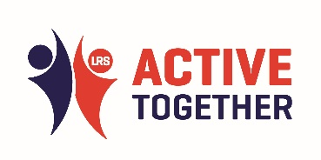
Active Together Conference: Workshop (LTC)

ACTOR | BEHAVIOURS
NHS, Local Government, Planners, Housing, targeted conversations through LTC | Stop stereotyping, personalisation, ask what is needed/when and how/where/with who. ‘Can Do’ approach, just need to try. Difference can be hard to measure. Don’t discuss progress in terms of success/failure or ask what the goal etc is for that person (back to personalisation),measurement of success or failure should be determined by user.
Social care, secondary care staff/clinicians, point of diagnosis. Commissioners, NHS & local government. Education – understanding the benefits. Planning – building nice places to be active.  GP’s/health professional, giving the right information. Social prescribing  Physio – pre/post op care – signposting to continue physical activity. | See physical activity as their business  Talk about the bigger picture, more holistic. 1 prevent.  All of us – peer support is so important  Measure what matters to people – nice environment. Access to trees.  Encouragement
Community members  Leisure centres  United Leicester  Professional sports clubs  Sports groups  Social groups  Too much policy | Share ideas  Joint programmes  Referrals  Policy reviews  Co-design  Awareness  Signposting  Funding
Physical activity development officer  Leisure providers  Volunteers  Social prescribers  Social groups (either)  GP’s and practice managers  School teachers  Facilities  Culture | Communication  Accessibility – improving access to options. GP’s being more aware  Improving awareness of benefits of physical activity  More promotion – champions  Cost  Language changed from physical activity to movement  Encourage physical activity in a younger cohort

Key Takeaways:
- Who are our local changer makers in this space
- How can we be braver when presenting data/ impact i.e. what is the cost of inactivity to the system
- Relooking at comms- Debbie found a support group that included physical via a poster in the breast clinic
- Importance of intersectionality and the layers of barriers to physical activity
- Finding a way for people to be active that works for them
- Locally across Leicestershire we are moving in the right direction to support residents with long term conditions (We Are Undefeatable, how people access physical activity opportunities)
- We need to continue to push the message ‘benefits outweigh risks’ both publicly and with partners

